Attaching Machine – Daily Cleaning Procedure
/tmp/in/input.doc

Safety:
- Be aware of pinch points in and around the glue rollers.
- Watch your head and shoulders as you move around the machine so as not to bump into the Feeder Table.

Materials Required:
- Rags, Bucket with Warm Water, Plastic Cup, Spatula, T-Handled Allen Wrench, M12 Pot Devin Release-Cote Spray, Cart

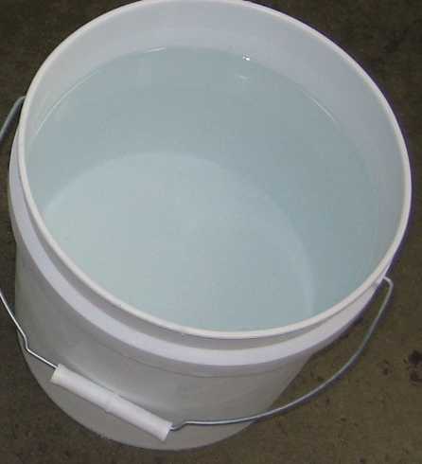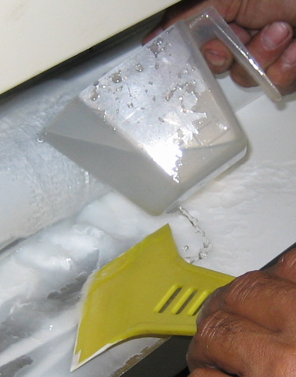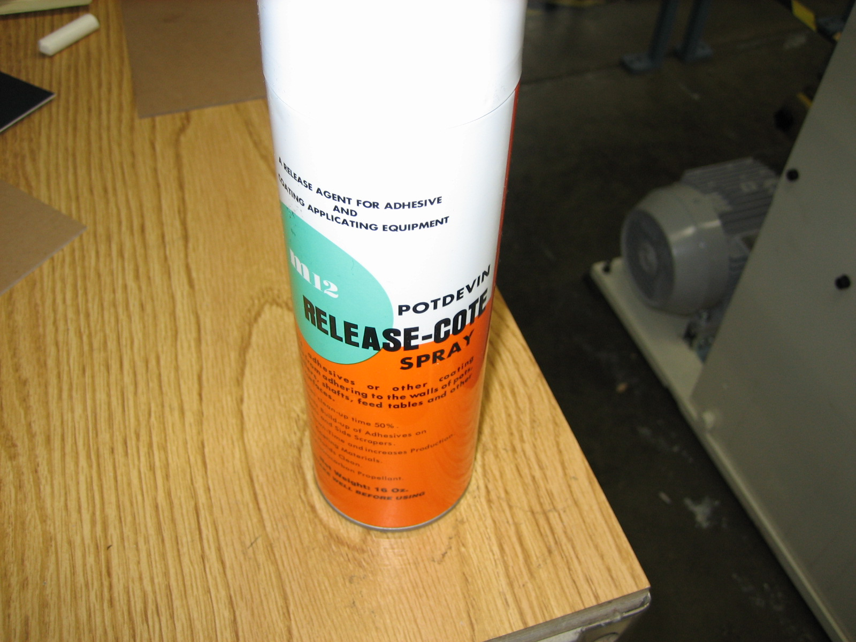

Procedure:
- Make sure the overfill bucket is in place and the green tube is inside the bucket.
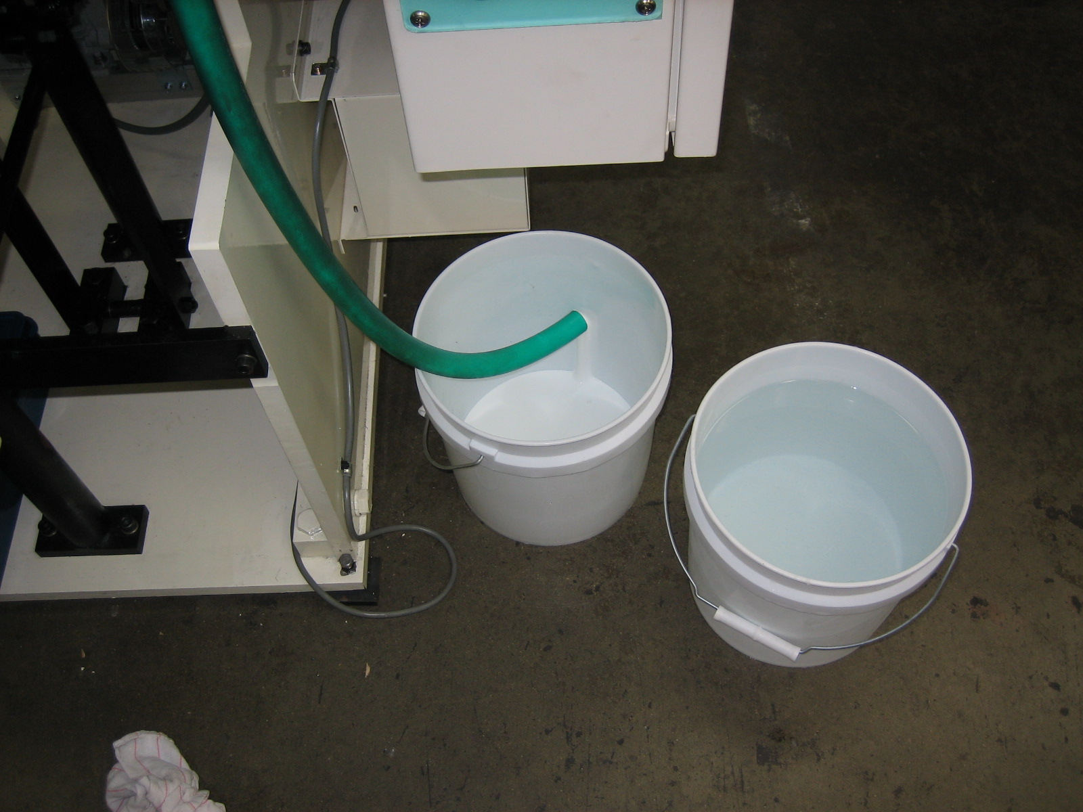

- Remove the glue drain plug from inside of the glue pan.

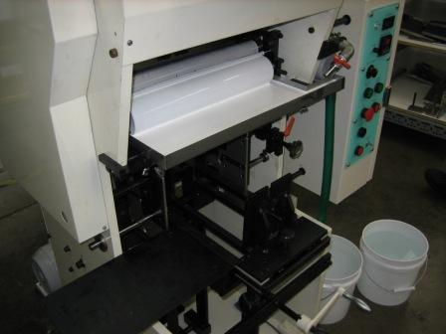 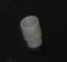 This is the glue drain plug

- Loosen the 2 wing nuts on the underside of the glue pan. This allows the left side to float up and helps direct the glue towards the drain hole.
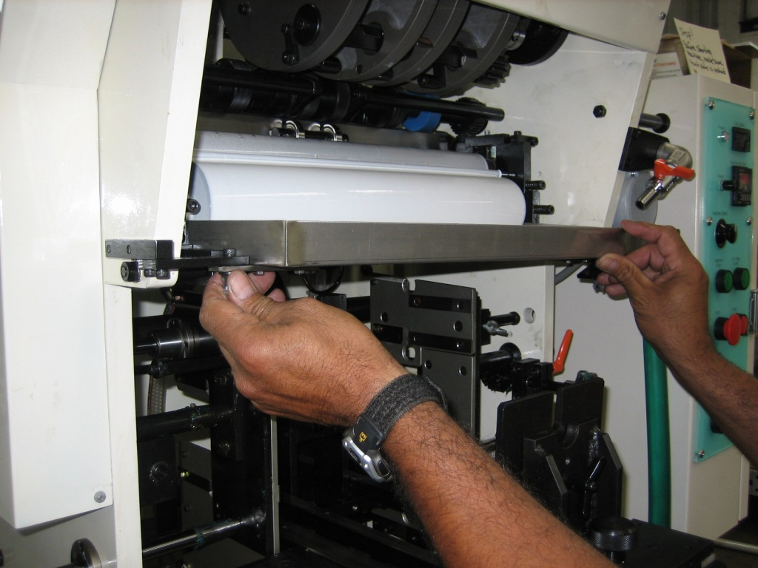

- Using the spatula, push the glue in the pan towards the drain hole
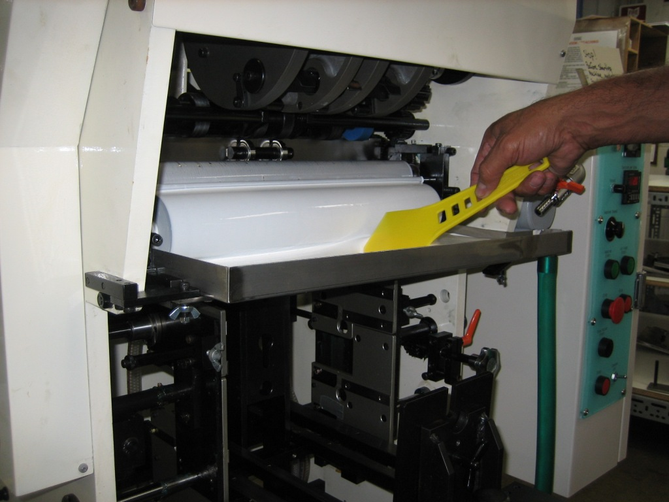

- Using the plastic cup, rinse off the rollers
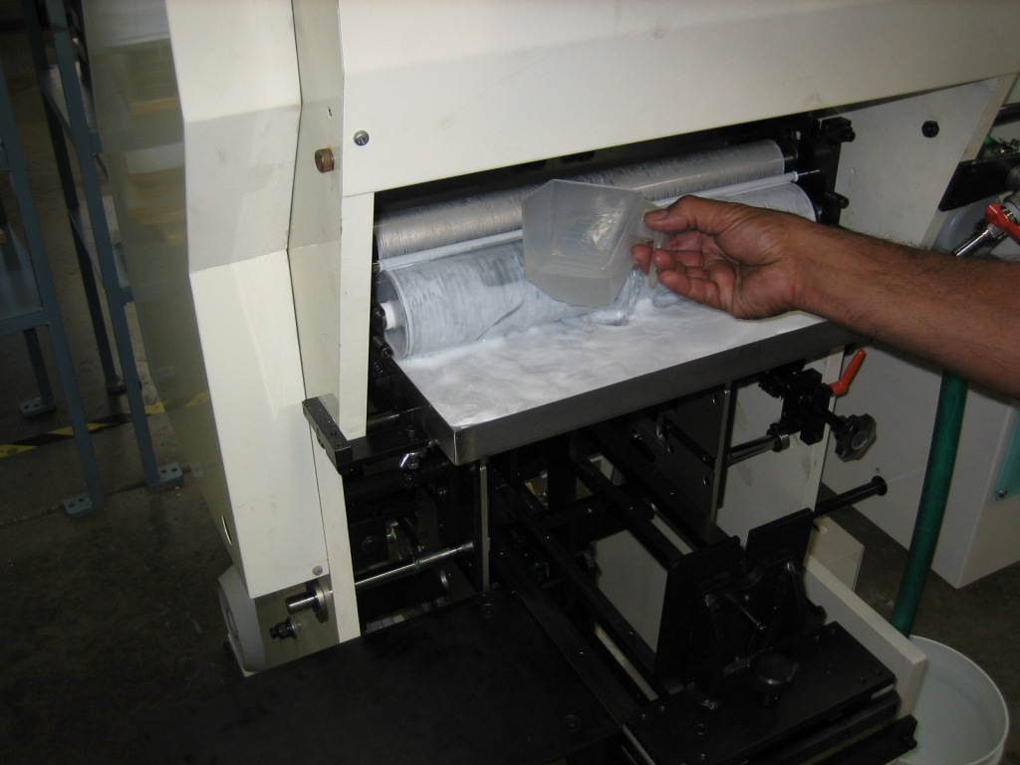

- Once the rollers are fairly clean and the glue pan has been emptied, use the T-handled allen wrench to remove 2 mounting screws, one on each side of the roller assembly. Place the screws on cart.
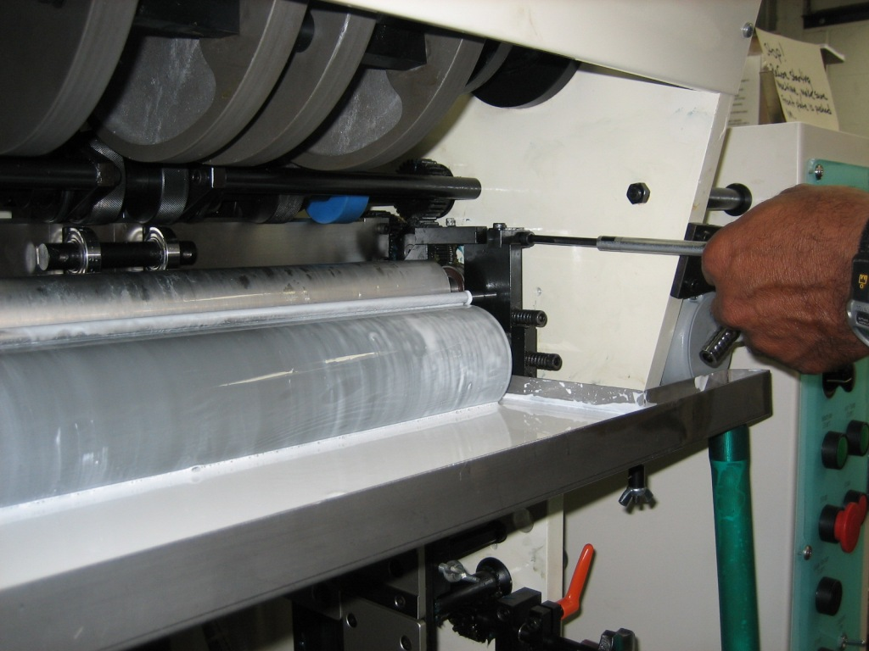

- Pick up the roller assembly as shown and slide the unit towards you to the front station for additional cleaning.
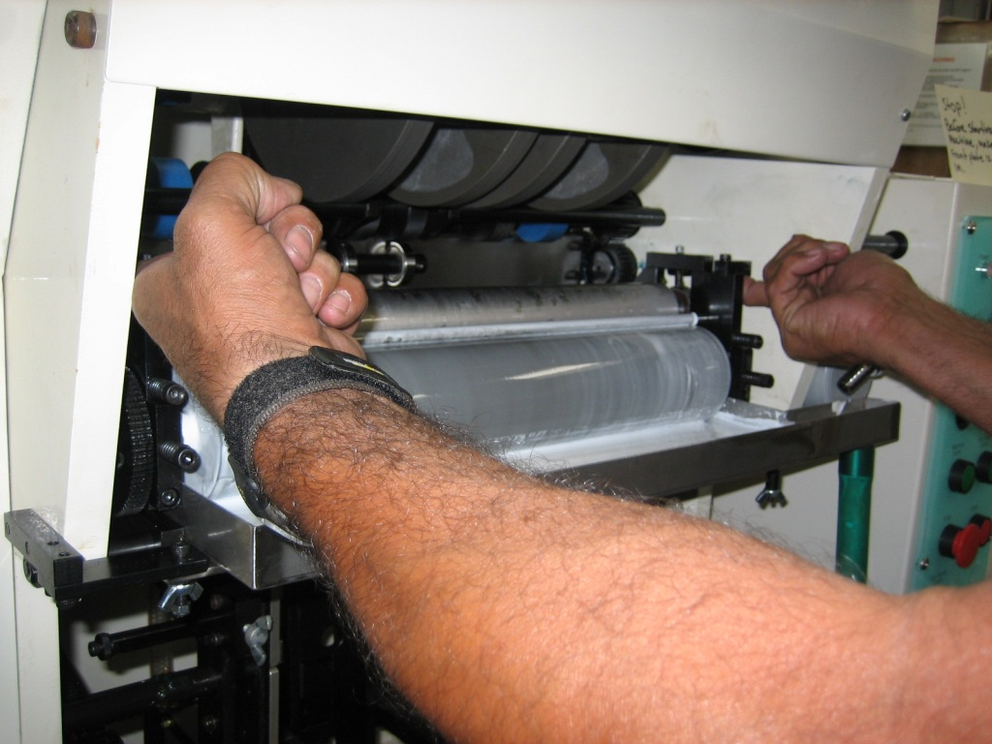 Rollers at front position: 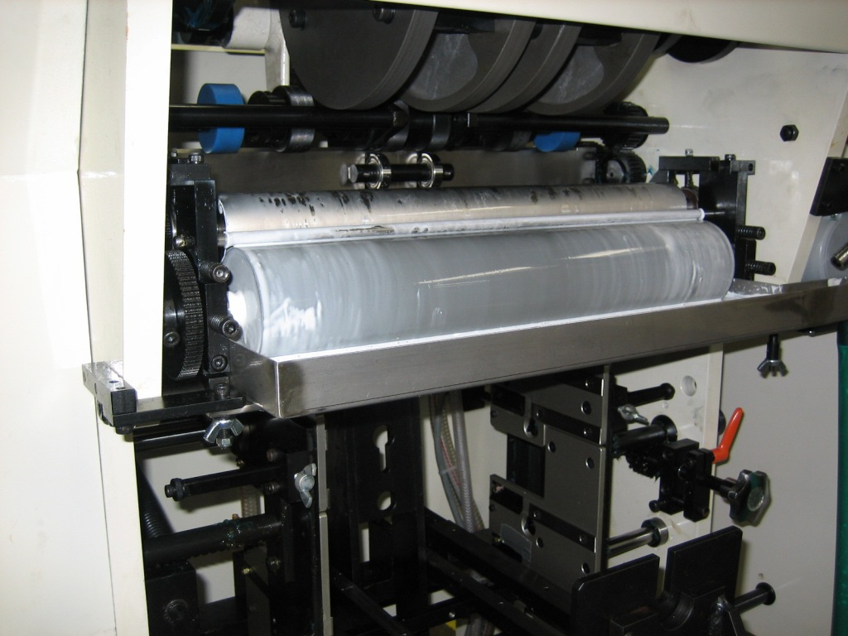

- Continue to clean the rollers using the plastic cup, warm water and the spatula. Use the control panel buttons “Glue Roller Start” and “Stop” to jog the rollers for better access in cleaning them. These are the bottom most buttons on the panel.
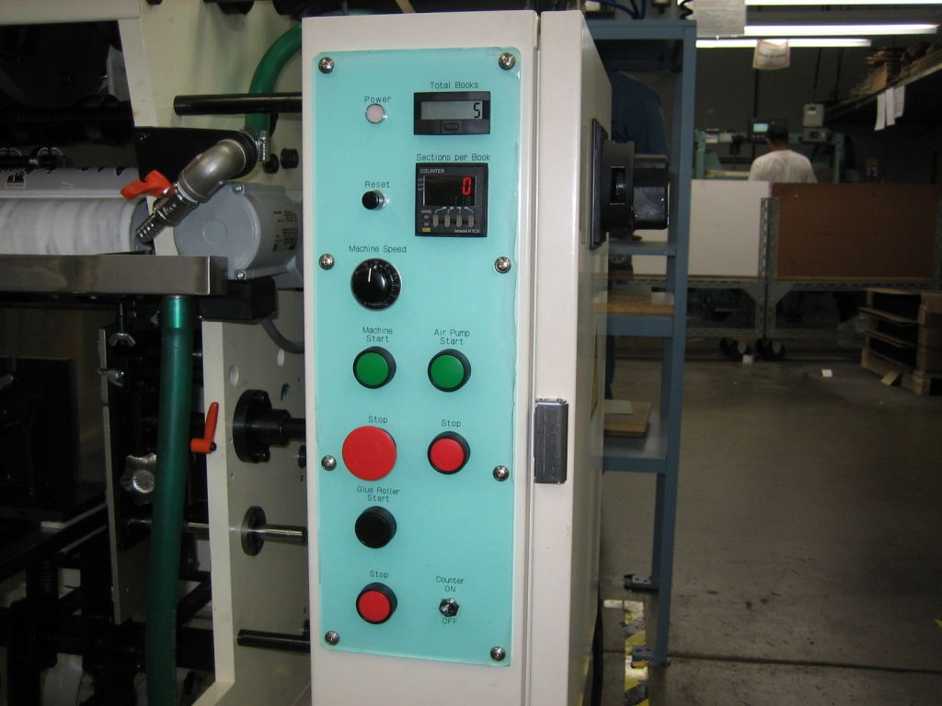

- One the rollers have been cleaned to point shown below, position the work cart near the machine and remove the roller assembly from the attaching machine.
Cleaned rollers: 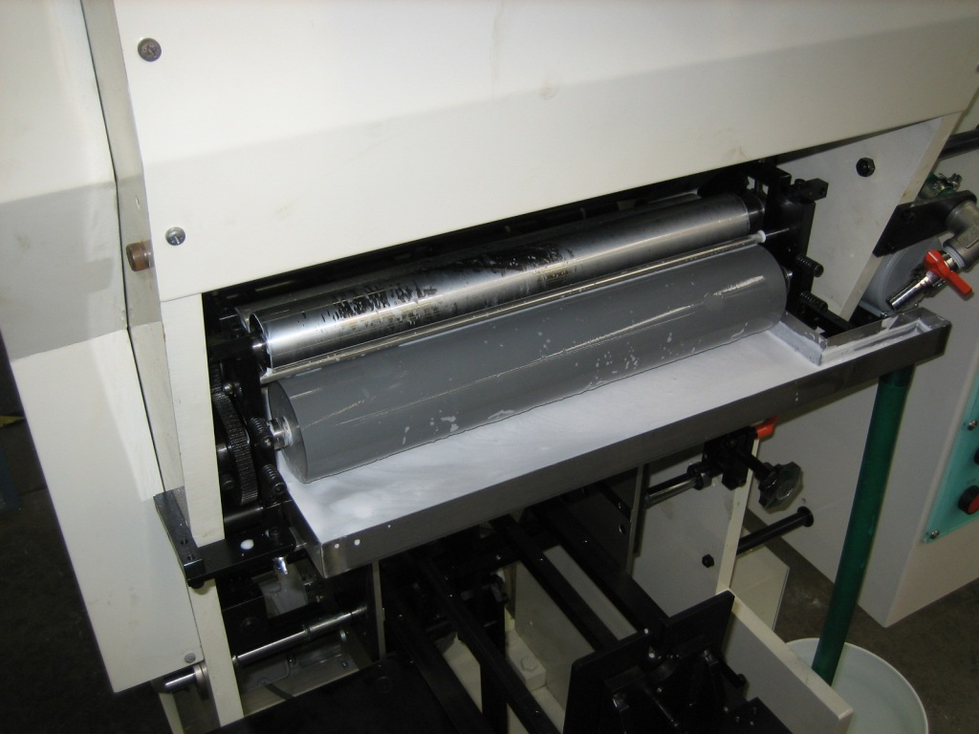
Roller assembly removed and placed on cart: 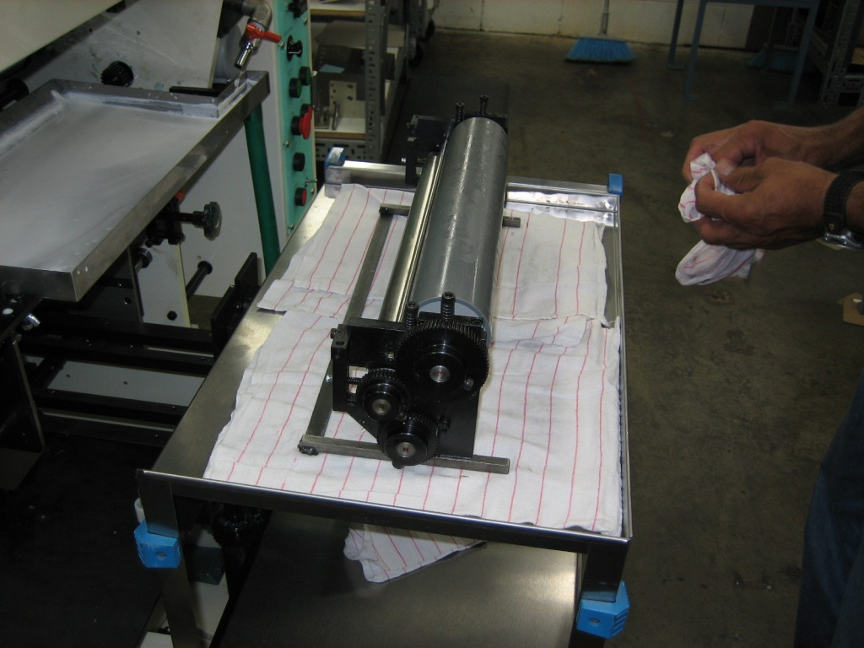

- Once removed to the cart, wipe down the rollers thoroughly. Hand rotate the gears to ensure everything is clean.
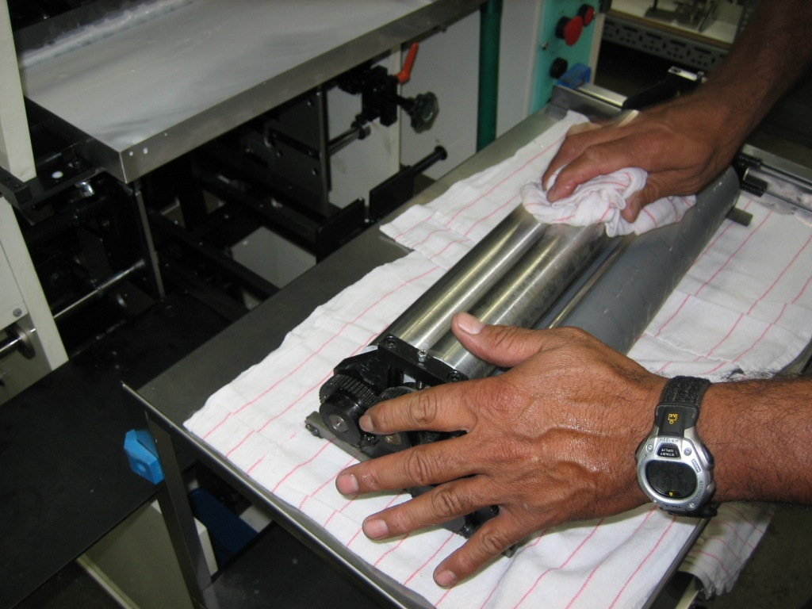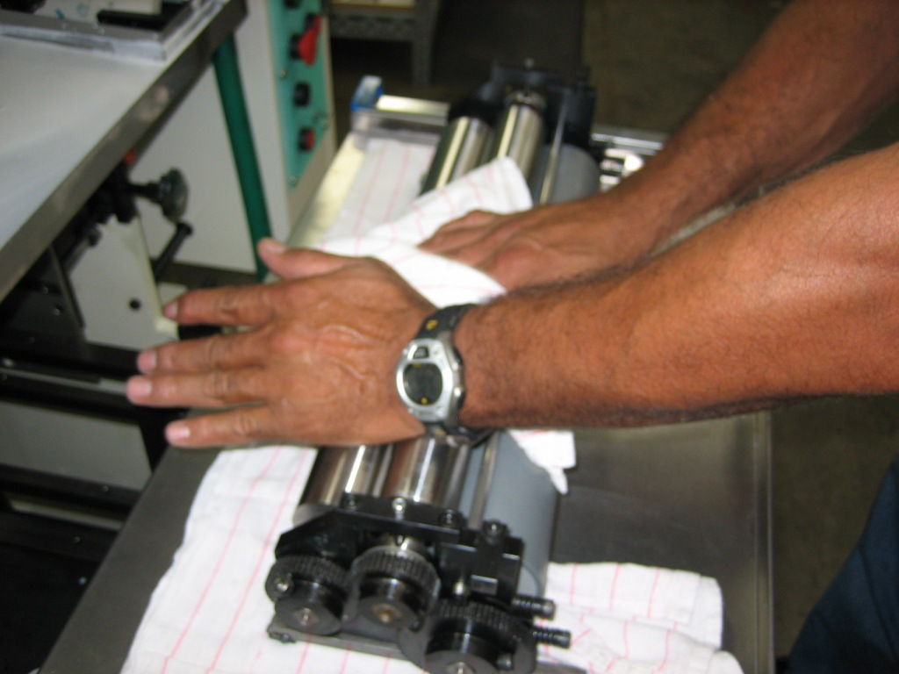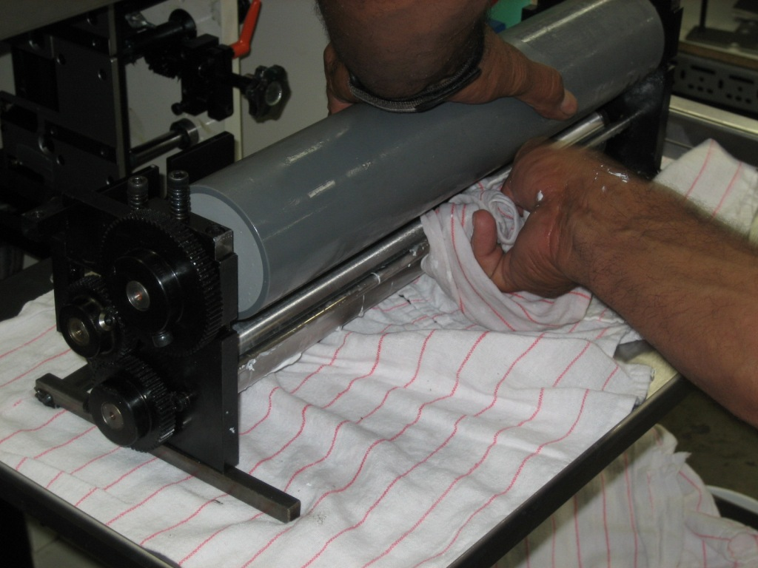

- After cleaning the rollers, spray them with M12 Pot Devin Release-Cote Spray.
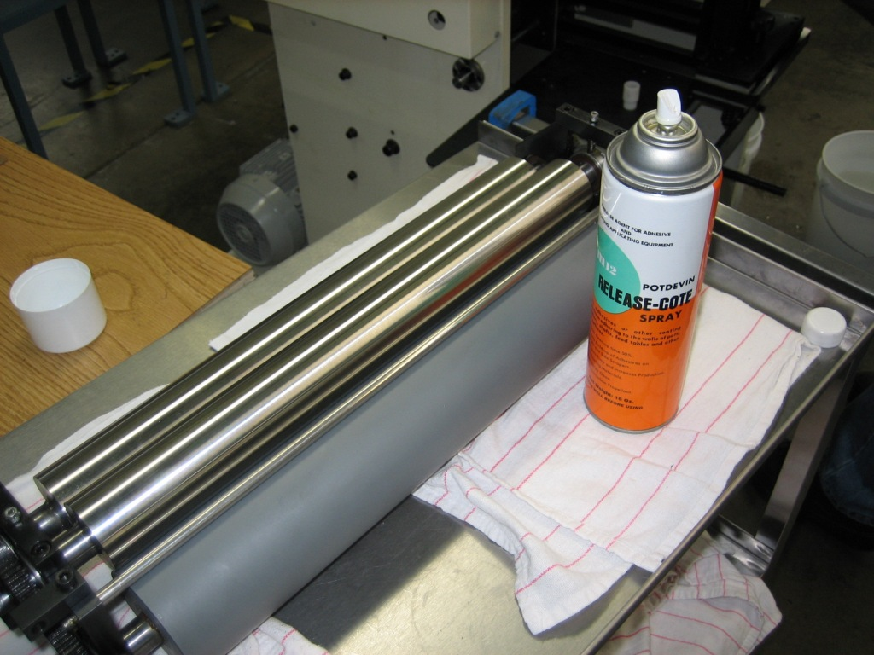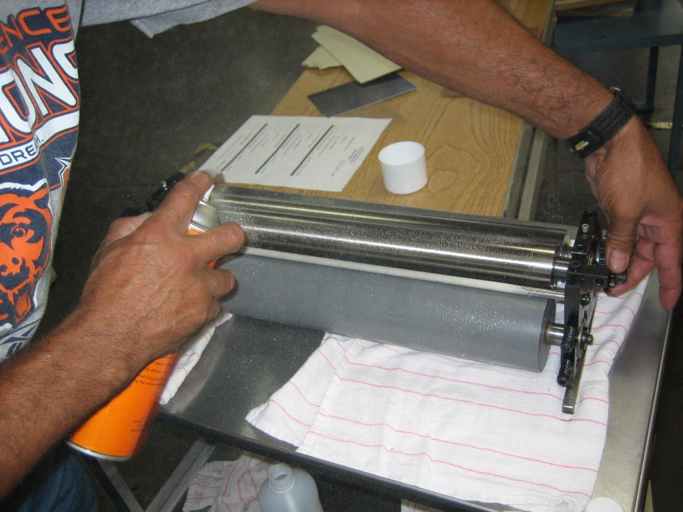

- Next, remove the glue pan and carefully take it to the wash station and clean it thoroughly.
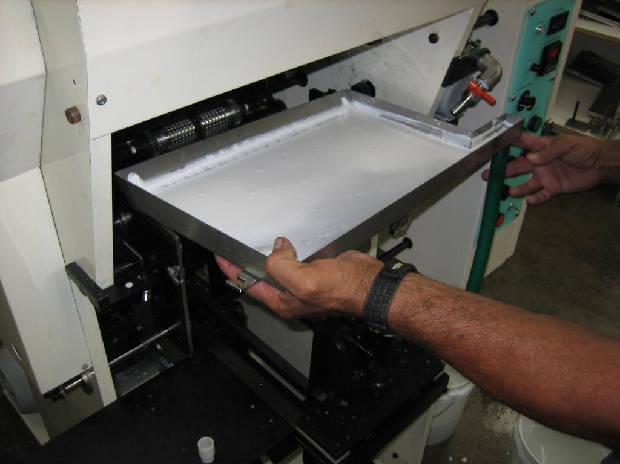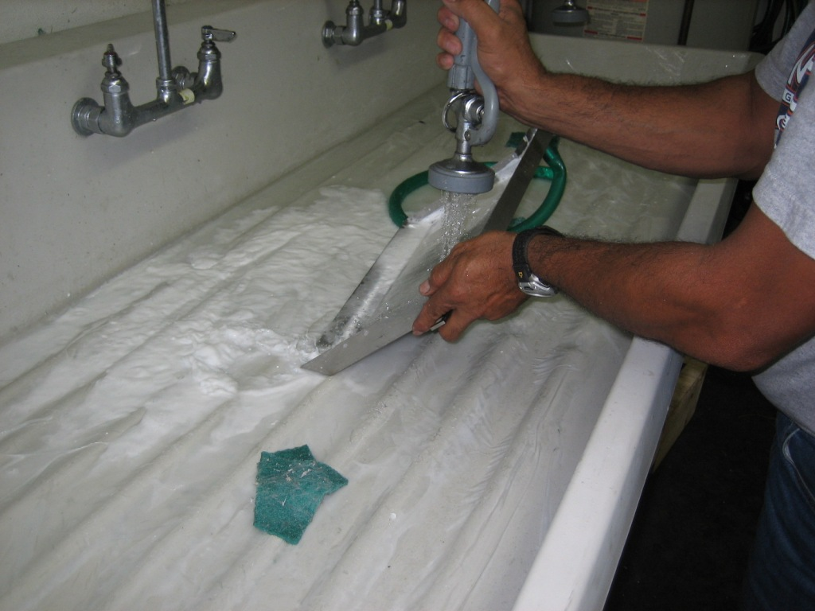

- Coat the glue pan using M12 Pot Devin Release-Cote Spray.
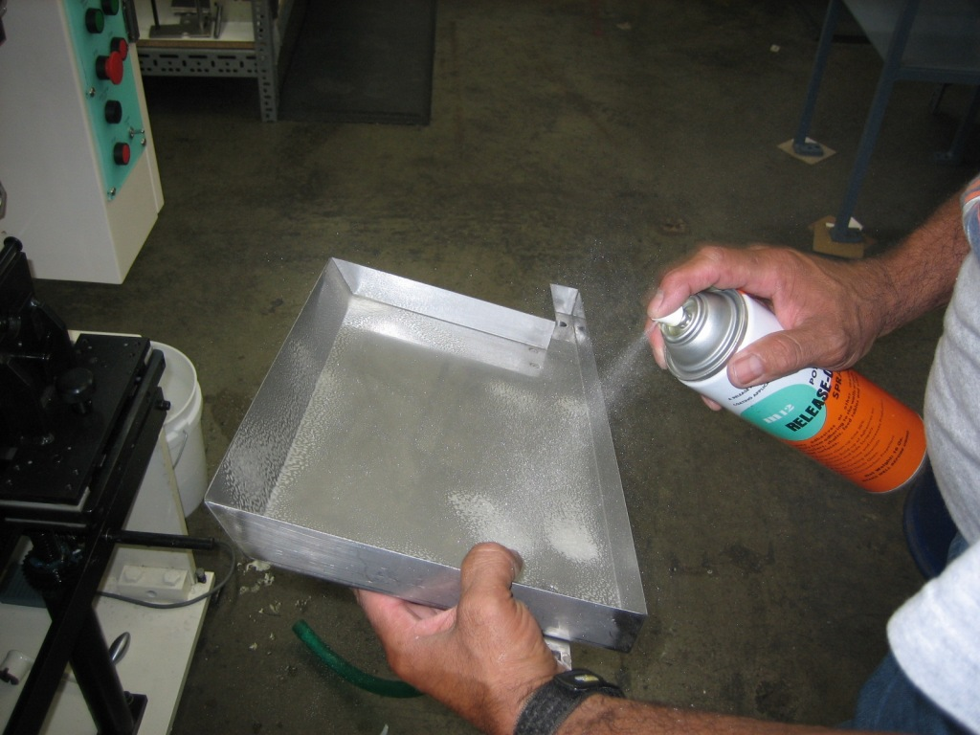

- Reinstall the roller assembly. Ensure the unit is in the back position. Use the T-handled allen wrench to tighten the mounting screws

- Reinstall the glue pan. Hand tighten the wing nuts. The cleaned unit is shown below.
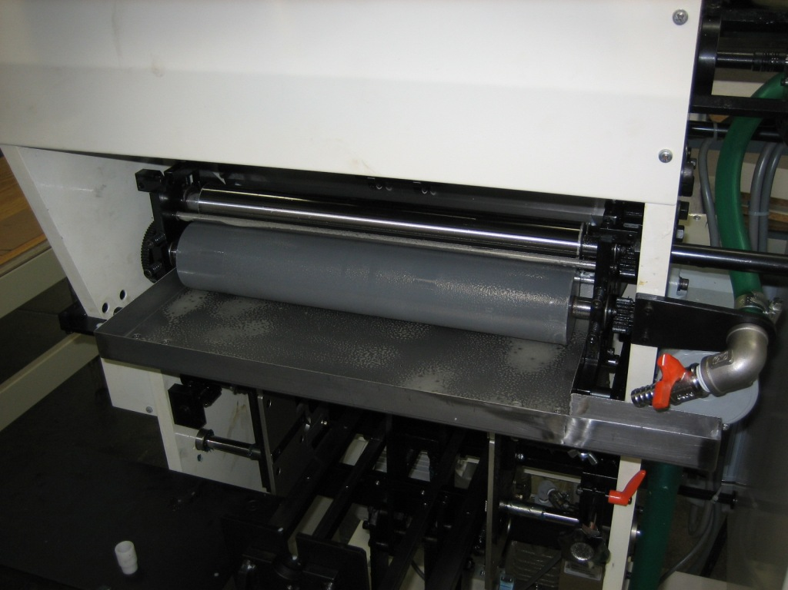

- Reinstall the glue drain plug.

