Attaching Machine – Operational Procedures
/tmp/in/input.doc

Safety:
- Be aware of pinch points in and around the glue rollers.
- Watch your head and shoulders as you move around the machine so as not to bump into the feeder table.
- Do not place hands in sheet feed area near air suckers/gripper.

Materials Required:
- Rags, Overflow Bucket, Attaching Glue (p/n 56-0595)

INSERT PICTURES

Procedure:
- Make sure the overfill bucket is in place and the green tube is inside the bucket.
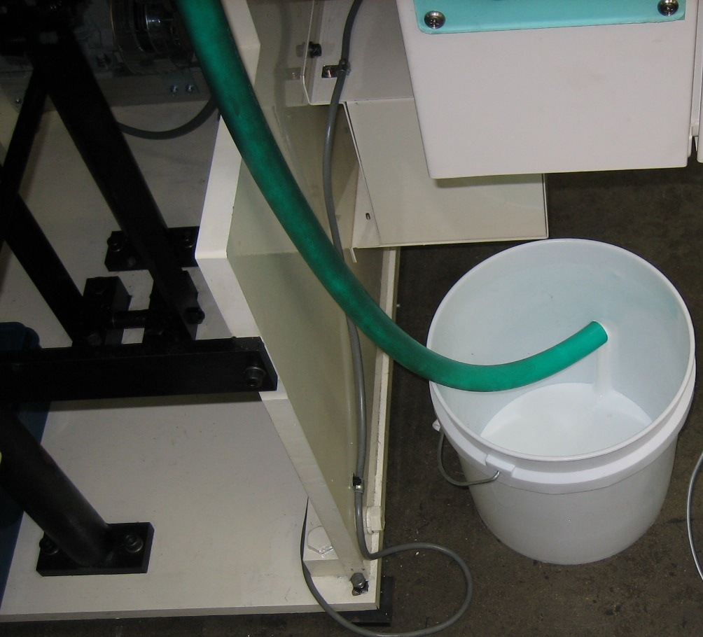

- Ensure that the glue drain plug is positioned inside of the glue pan.

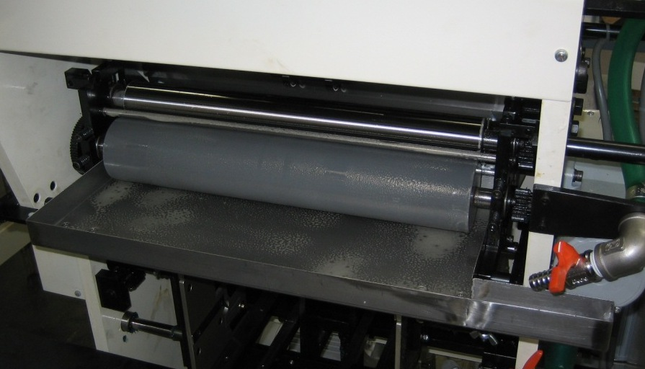 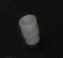 This is the glue drain plug.

- Fill the glue pan using attaching glue (p/n 56-0595) to a height half way up the drain plug.

- Turn the power on to the machine.
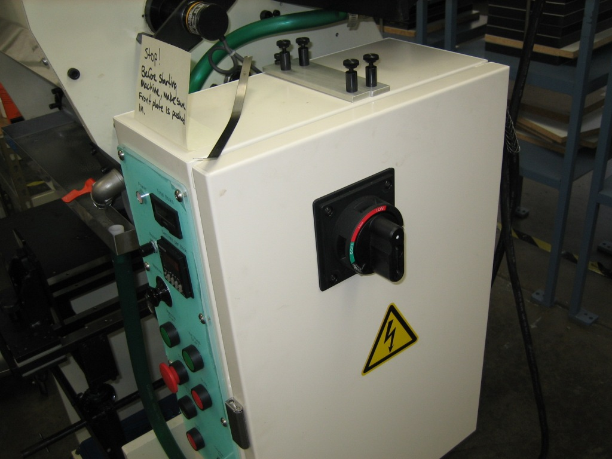

- Load the rollers with glue by pressing the “Machine Start” button located in the middle of the control panel.
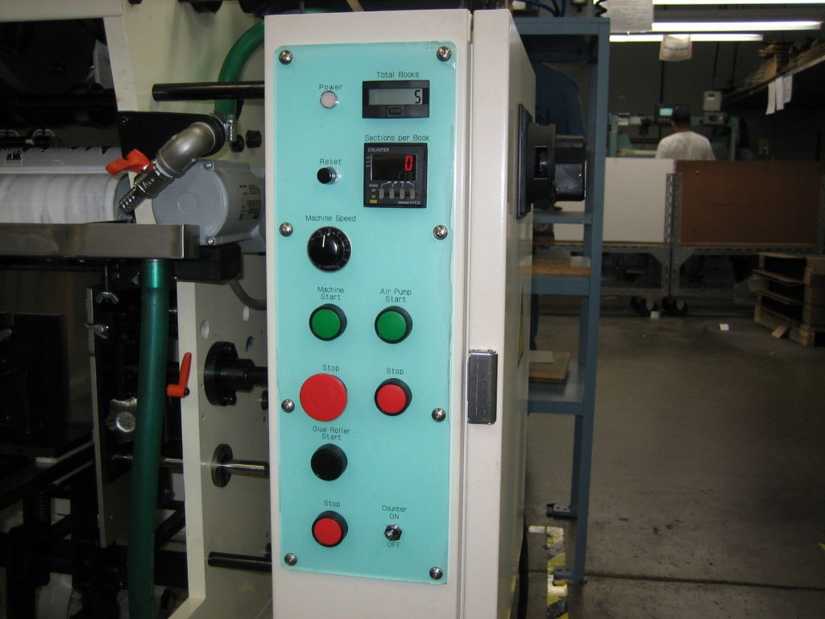

- Using your index finger, CAREFULLY touch the Glue On/Off roller along its length to ensure that there is enough glue being applied to it.

INSERT PICTURE

- To adjust the amount of glue being applied to the Glue On/Off roller, use the T-handled allen wrench to turn the Glue Adjusting Screw (top screw) either

  - Clockwise – for less glue

Or

  - Counter clockwise – for more glue

