

Owner’s Manual

Frameware Saber™ Machine

For Accurate and Efficient Saw Tooth Hanger Installation

Model: 400
ASM
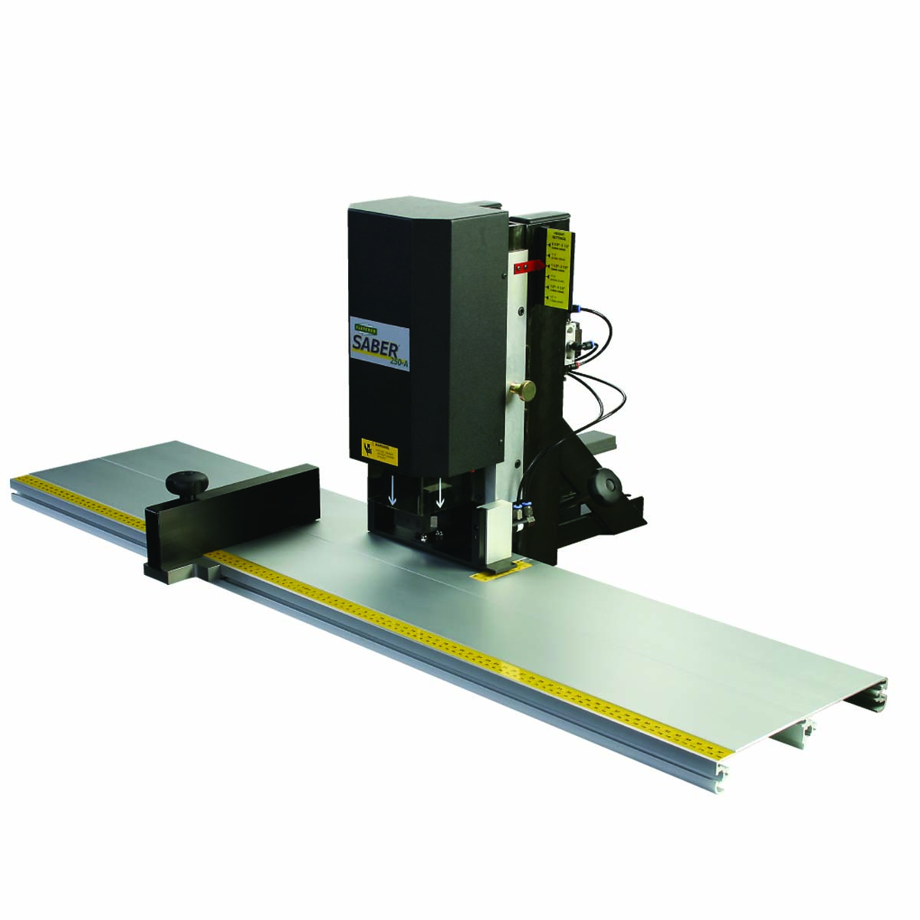

Frameware Inc.

8 Audrey Place • Fairfield, NJ USA 07004
Tel 973.808.2022 or 800.582.5608 • Fax 973.808.0262 • www.framewareinc.com
sales@framewareinc.com

First, we’d like to congratulate you for adding the Saber 400 ASM to your production line. From now on your operators will be able to insert saw tooth hangers with efficiency, accuracy, and reliability. It’s easy to use and designed to require minimal maintenance. Regardless of the size of the frame or thickness of the moulding, the Saber will secure a 5-tooth hanger perfectly placed and instantly secure.

Next, we ask you to inspect the two containers that were used to ship the Saber. If damaged, please contact your carrier and file a claim. Locate the warranty card that was shipped with this manual and return it to Frameware Inc. to activate the warranty.

Now, you’re ready to set up and operate the Saber.
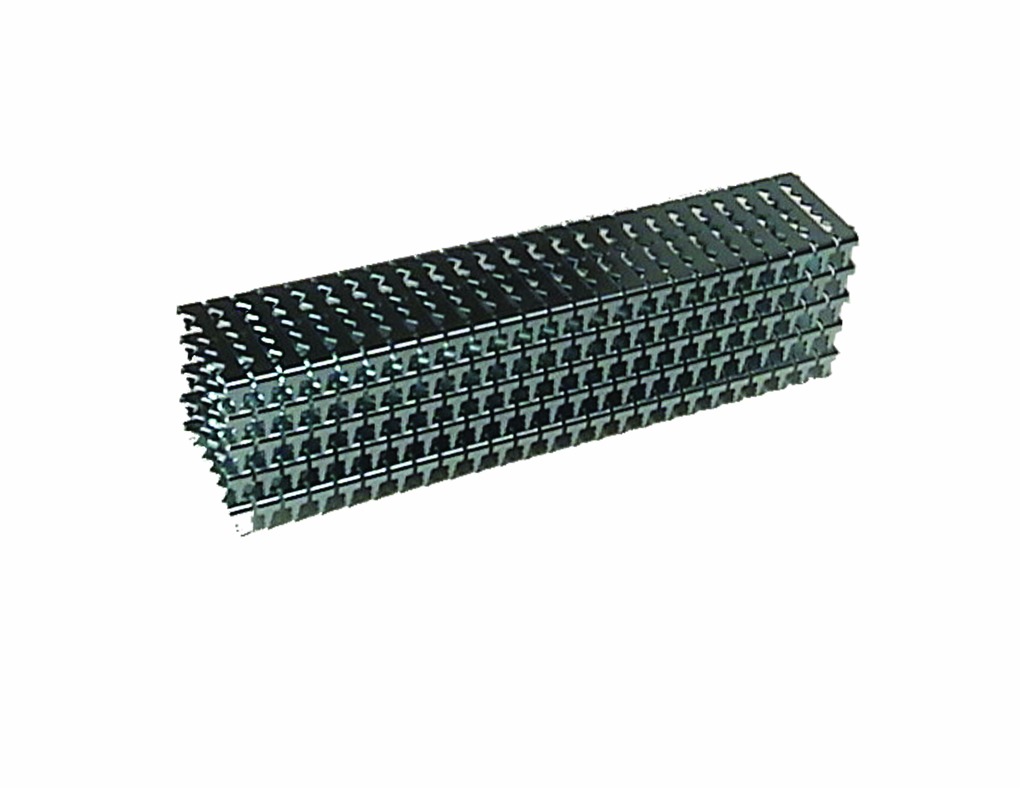

Contents:

Safety First! Page 2

Setting Up Your Machine Page 3

Operating the Saber Page 7

Optional Equipment Page 12

Troubleshooting the Saber Page 14

Maintenance & Replacement Parts Page 18

Page 1
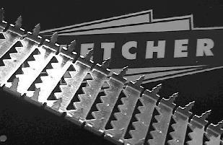

Product Warranty
Frameware Inc. warrants the machine purchased to be free from defects in parts and workmanship for (1) one year from the date of purchase. Frameware Inc. warrants that it will repair or replace any such defective machine or replace parts, providing the machine has been under normal use and service and the defective part or machine is returned to Frameware at the purchaser’s expense. Frameware Inc. must authorize the return in writing. Proof of purchase must be submitted to validate warranty coverage. This warranty is in lieu of all other agreements and warranties expressed or implied. Frameware Inc. does not authorize any company employee or representative to assume for it any other liability than that set forth in this Product Warranty.

Page 1

Please read through this manual before operating the Saber™ 400 ASM. If after reviewing these pages you still have questions about the machine please contact Ron: (toll-free) 1.800.582.5608 or e-mail at: ron@framewareinc.com.

- It is the employer’s responsibility to enforce compliance with these safety warnings and procedures by all users of the Saber machines. Keep this manual available so all employees have access to it and the opportunity to review procedures periodically.

- The intended purpose of the Saber is to insert saw tooth hangers in picture frames of various shapes, sizes, and materials. It must not be modified or used for any other application or purpose.

- Use safety glasses. The operator of this machine, and others in the work area, must wear safety glasses with rigid side shields. Wear ear protection. Ear protection is recommended in any work environment where repetitive, mechanical machinery is in operation.

- Only connect the Saber to an air supply with a coupling that removes all pressure when disconnected. Always disconnect the machine from the air supply before performing maintenance, removing a jam or cleaning the Saber. Even if a hanger strip is not visible on the guide, assume that there may be one or two hangers remaining in the machine.

- Use clean, dry, regulated compressed air at a minimum pressure of 100 PSI at 2 CFM. The system includes a filter and pressure regulator. Do not connect this machine to an air supply with maximum potential pressure greater than 150 PSI.

- Never use oxygen, carbon dioxide, combustible gases or any type of bottled gas as a source for this machine. Explosion and serious injury may result.

- Never use the machine if the air supply is compromised, the machine is missing parts, or repair of the Saber is required. Do not use the machine if the safety warning labels are missing or unreadable. Do not use the machine if the ram safety guard is missing or broken. Contact a Frameware Inc. Sales Representative for replacement labels or parts.

- Only use the parts, supplies, and accessories that are recommended by Frameware Inc.

- Use care when loading the hanger strips onto the hanger guide, making sure that you do not inadvertently activate the T-bar switch or step on the foot pedal.

- Do not over-reach or use the Saber from an awkward or insecure position. Make sure that the work area is well lit, free from clutter, and set up in a way that promotes proper ergonomics.

Page 2

Unpacking the Saber
400 ASM
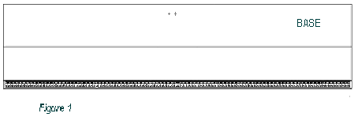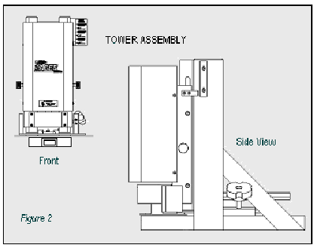

The Saber has been shipped to you in two containers. The longer, flatter carton contains the Base (Figure 1).

The other box contains the Tower Assembly (Figure 2), the Fence (Figure 3), and a Parts Bag.

You will have found that the Parts Bag contained:

- This Owners’ Manual

- A Warranty Card

- Flat Head Socket Cap Screws (2)

- Hex Key (1)

- Triangle Template [for squaring] (1)

- Foot Pedal Assembly
(packaged separately)

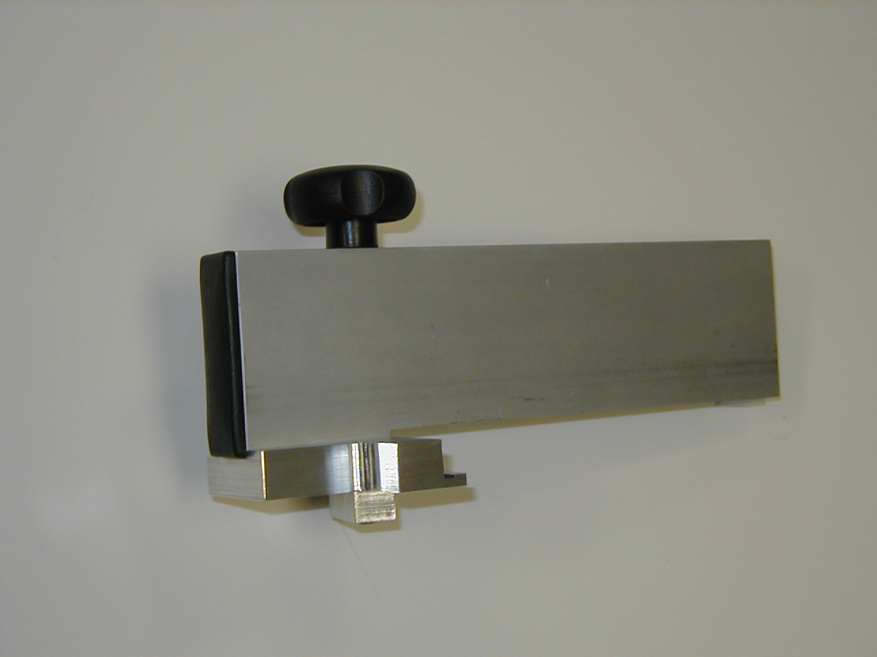

Figure 3: Fence

All instructions in this manual assume that
you are facing the front of the machine and
that the machine has been placed on
a flat and secure surface.

If anything is missing, please contact Ron at Frameware Inc. at 800.582.5608 or at 973.808.2022, or ron@framewareinc.com.

Page 3

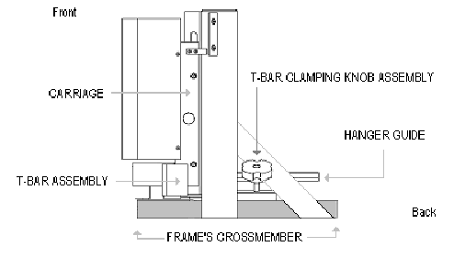

VIEW A: FROM RIGHT SIDE
Figure 4

Page 3

VIEW B: FROM THE FRONT
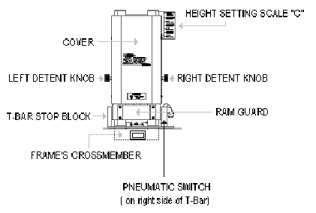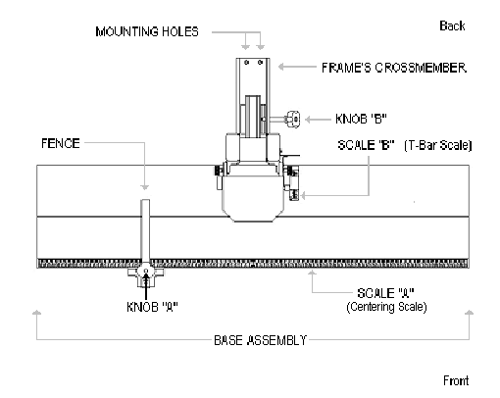

VIEW C: FROM ABOVE
Figure 5
Figure 6
Page 4

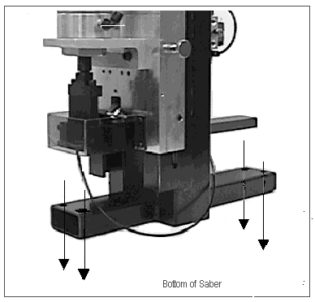

Before assembling the machine, determine whether you will anchor the Saber to your work surface. Placing and securing the machine will be a matter of personal preference and it is left to the owner to decide how best to use the Saber.

The Saber should be placed so that the front of the machine is facing the operator. Be sure to leave sufficient room for attaching the base assembly. The base assembly will run along the front edge of the workstation.

If you decide to anchor the Saber to your work surface, locate the four, predrilled holes on the cross member of the frame (Figure 7). These will allow you to secure the machine with four bolts (not included).

Please Note:

When the base is attached to the tower, a squaring procedure must be followed to ensure proper alignment.
(See Figure 8)

Figure 7 (Shown with machine’s cover removed)

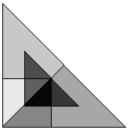
Page 5

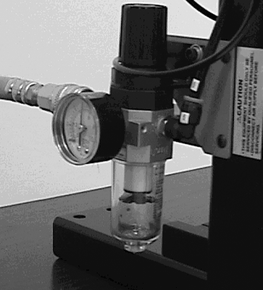
THE MACHINE IS NOW PROPERLY SQUARED AND YOU MAY ATTACH YOUR SOURCE OF COMPRESSED AIR TO THE FILTER / REGULATOR AT THE LEFT REAR OF THE SABER. (Figure 9)
Page 6

Figure 8: top view

Attach the base to the tower assembly by placing it atop the machine cross member. Align the screw holes and insert screws. Loosely tighten the left, but do not tighten the right screw. The right screw will not be tightened until the squaring procedure is complete. Attach the fence assembly and position it at the 10” mark on Scale A.
2.
With the machine properly placed (and optionally mounted to the work surface), raise the carriage to its uppermost position on the tower. Pull out the detent knobs to release the carriage and guide it upwards until it locks in place when it reaches the appropriate location.
1.
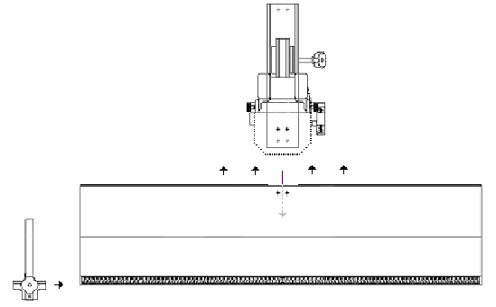

Set the T-bar to a 2-inch depth setting. Do this by loosening the T-bar clamping knob and moving the entire T-bar assembly until a 2-inch setting is reflected on the T-bar scale. Tighten the knob.
3.

Place the enclosed triangle template squarely against the fence and across the T-bar assembly. Use a piece of material or matting (approximately 1/8” thick) as a platform under the template to ensure that the triangle will bump up against the fence and the T-bar assembly.
4.

Gently move the base assembly until the triangle is perfectly squared to the fence and T-bar. When you have done so, securely tighten the right screw and then the left.
5.

Establishing a Proper Air Supply:

Attach your compressed air hose to the machine using clean, dry air (minimum 100 PSI with the regulator set at 75 PSI).

You may choose to adjust pressure depending on the size and material of the frame. This may be especially important if using the small frame adapter. (See “Optional Equipment”)

Certain safety precautions are required when using pneumatic tools in order to prevent injury to the user and others in the area. Read and follow all instructions and safety warnings in this manual.

Figure 9

Saw tooth hanger strips contain 25 collated hangers. Individual hangers are barbed to ensure maximum holding power when inserted into a frame.

The hanger strip is loaded onto the guide, barbs pointing downwards and teeth facing the machine operator, i.e., the front of the Saber.

Figure 10 (Top View)

A. Load the Hanger Strip

- Measure the Frame and Adjust the Machine

- Activate the Saber

A. Load the Hanger Strip

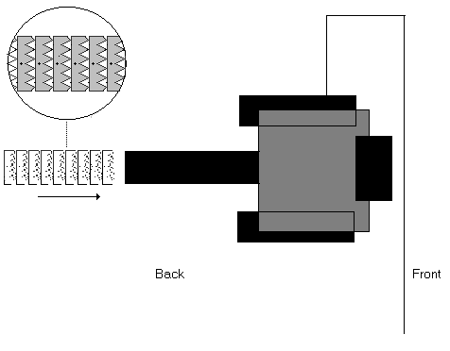
guide
Figure 10

The required hanger strips (part number FSH 400) may be ordered by contacting the Frameware Customer Service Department at 800.582.5608; or e-mail at:
sales@framewareinc.com

Once the strip is loaded onto the guide, the operator pushes the strip forward toward the front of the machine until the hanger strip stops.

Page 7

B. Measure the Frame and Adjust the Machine

Figure 11

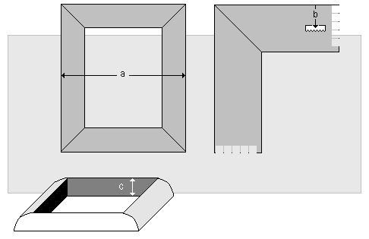

The Saber requires the operator to determine three measurements before proper placement of a saw tooth hanger can be made:

- The width of the frame;

- The hanger’s placement from the top of the frame to the centerline of the hanger;

- The height or thickness of the frame.

Coming Up:

Page 9: Instructions for taking measurements and adjusting the Saber.

Page 10: A quick review, product notes, and safety tips.

Page 11: How to drive a saw tooth hanger using the Saber.

Page 8

Taking measurements and adjusting the Saber:

- A. How wide are the frames you will be processing?

- Measure the width from outside the left edge to outside the right edge of the frame. (measurement “a” in Figure 11)

- Locate the Fence assembly and loosen it by twisting Knob A, counterclockwise.

- Slide the Fence until its edge is aligned with the mark on the Centering Scale, Scale A, that corresponds to the frame’s width.

- Tighten Knob A.

- B. Where do you want the hanger to be inserted, relative to the top edge of the frame?

- Measure or approximate the distance between the top edge of the frame and the point at which you wish to insert the hanger. (measurement “b” in Figure 11)

- Loosen the T-bar Clamping Knob, Knob B, by turning it counterclockwise.

- Move the T-bar Assembly by gently pushing or pulling the unit along its track.

- Align the T-bar so that measurement “b” is reflected on the T-bar scale, Scale B, located on the Base Assembly.

- Tighten Knob B.

- C. How high is the frame at its greatest thickness?

- With the frame laying flat on a surface, determine its height at its thickest cross-section. (measurement “c” in Figure 11)

- The Carriage of the Saber is spring-loaded and slides up and down the tower of the machine.

- Firmly pull out the left and right Detent Knobs at the same time.

- You will notice that doing so will free the Carriage to glide up or down as you wish.

- This movement of the Carriage will cause the Height Setting Pointer to move along the Height Scale, Scale C, at the upper right hand corner of the machine.

- The Carriage will lock into any one of six (6) pre-set positions that correspond to a range of heights.

- Find the range that includes measurement “c.”

- Feel for the locking location at that range by gently releasing the Detent Knobs at or near the correct setting.

- Fully release any pressure on the Detent Knobs to lock the Carriage in place at the appropriate height setting.

Example “A”

A frame measures 10” across. After loosening the Fence with Knob A, move the Fence so that the Centering Scale (Scale A) reads 10”. Tighten the Knob to lock the Fence in place.

Example “B”

After assessing where a hanger should be placed on a certain frame, the operator measures the distance from the top edge of the frame to that spot and finds it to be two 2”. The operator then moves the T-bar assembly to 2" on Scale B and then locks the T-bar assembly in place by turning Knob B.

Example “C”

A frame measures 2.3” high at its greatest thickness. Using the Detent Knobs, the operator locks the carriage into place at the 1.5” to 2.5” setting as marked on the Height Scale (Scale C).

Please Note:

The Height Scale
(Scale C) shows 6 different height ranges. Choose the one that will best accommodate measurement “c.”

2.5” to 3.5” (64 – 89mm)
2.0” to 3.0” (51 – 76mm)
1.5” to 2.5” (38 – 64mm)
1.0” to 2.0” (25 – 51mm)
0.5” to 1.5” (13 – 38mm)
0.5” to 1.0” (13 – 25mm)

Page 9

Please Note:

While this manual uses non-metric measurements in most of its examples, the Saber has both imperial and metric scales.

Let’s Review:

- You have read and understand the safety instructions listed inside the front cover of this manual.

- You are familiar with the operating procedures and safety guidelines of your employer.

- You are wearing safety glasses prior to working with this equipment.

- You have assembled the Saber and have created an uncluttered work area for the machine.

- It is securely positioned (possibly mounted) on your work surface.

- You are familiar with the major components of the Saber and know that three measurements must be taken before adjusting the machine to your run specifications.

- The machine has been connected to your source of clean, dry, compressed air, according to the specifications listed on the bottom of page 6, and in compliance with your company’s operating procedures.

The Saber has been designed to deliver precise installation of saw tooth hangers with great reliability. If, for any reason, a hanger jams, the machine will not fire.

Set the carriage so that there is a minimum clearance of 0.25" from the frame to the bottom of the ram guard. Keep in mind that the machine will operate properly with greater clearances, but there is less room for errors or injury when this space is kept to a minimum.

Safety Tips:

It is recommended that the hanger be driven at the thickest portion of the frame. The further it is driven from a thick portion, the more likely it becomes that the frame will kick upward when the hanger is inserted.

Premature release of pressure from the T-bar switch or foot pedal will automatically interrupt the operation of the ram and return it to the uppermost position. This design feature prevents injury and unintended firing. Depress the switch or pedal again to install the hanger if it was not partially installed into the frame during the interrupted cycle.

Page 10

C. Activate the Saber
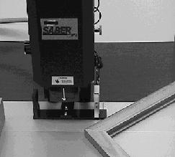

Once all three measurements (a, b, and c) have been taken and the machine has been readied with these dimensions reflected on Scales A, B, and C, the operator is now ready to insert the saw tooth hanger.

1.
The frame is inserted backside-up with its left edge pressed against the left fence.

2.
The top edge of the frame is leveled against the T-Bar assembly.

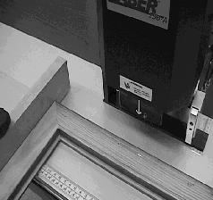

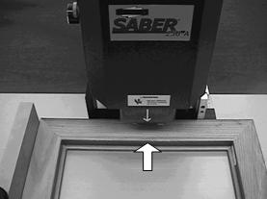

3.
The operator then pushes the frame squarely into the machine (against the T-Bar), and will depress the foot pedal.

4.
When the pneumatic cylinder is activated, the machine’s ram will insert the hanger into the frame at the proper location.

Page 11

The Saber 400 ASM can be outfitted with one or more of the following optional devices:

A. Small Frame Adapter (Part # 04-553): For frames that are too small (7” wide or less) to be processed using the standard T-bar assembly and/or pneumatic switch.

B. Additional Fence Assembly (Part # 04-551): The Saber comes equipped with a universal fence assembly that is used for squaring the left edge of a picture frame. It may also be used to square the right edge of picture frame that requires two side-by-side saw tooth hangers. When two hangers must be inserted into the top piece of a picture frame, a second fence assembly may be ordered (to attach on the right side of the base) in order to provide the operator with a time saving method of installing the hangers.

Using a Small Frame Adapter to Insert Hangers

Some frames are too narrow to be effectively handled by the standard T-Bar assembly of the Saber. Therefore, Frameware Inc. has designed an optional adapter that will accommodate frames less than 7” wide.

The adapter is fitted on the T-Bar stop block on the T-Bar assembly. The adapter’s bracket is securely tightened to the Saber by turning Knob D. Do not over tighten. The procedure for inserting the hanger is unchanged.
Note: Add ¼” to measurement “b” to compensate for the thickness of the Actuator Bar when setting the T-bar Scale. That is, if you wish to place the hanger ¼” from the top edge of the frame, add ¼” and set Scale B to ½”.
A. Small Frame Adapter

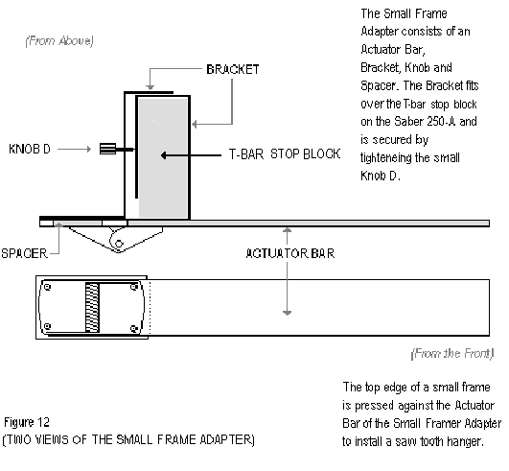

Page 12

B. Additional Fence Assembly

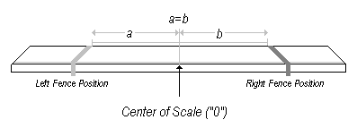

Figure 13
Inserting Two Hangers Per Frame Using a Second Fence.

- The fence designed for the Saber may be attached to the base on either the left or the right side of the machine. When inserting a single hanger, the fence is positioned to the left. If a frame’s size necessitates a two-hanger configuration, a second fence assembly may be used to streamline the process.

- The second fence is the identical twin to the standard fence. They can be used interchangeably. They are attached to the base the same way and are positioned so that there is a fence to the left of “zero” on the centering scale, and there is one to the right of this mark.

The procedure for inserting two hangers using the second fence is similar to the procedure for inserting one:

- Measurements are taken and the machine is adjusted to reflect them. Whereas a single hanger is centered on a frame, two hangers must be lined up horizontally at an equal distance from the center (or at an equal distance from the frame’s edge).

- The operator manually determines the placement of the first hanger and takes that measurement. The essential thing to remember is that the placement and measurement of the second hanger must mirror that of the first. Both fences must be positioned so that their corresponding edges are set to the same dimension on either side of “zero.” (See Figure 13 above)

- The installation process is completed by first inserting the right hanger. (Square the frame to the left fence before pressing it against the pneumatic switch to activate the hanger.) Repeat this process for the left hanger by squaring the frame against the right fence.

Page 13

For assistance, contact Ron at Frameware inc. at
800.582.5608, or ron@framewareinc.com.

Troubleshooting: Hanger Indexing

To correct saw tooth hanger feeding or “indexing” problems, it may be necessary to follow this procedure:

- Check the air pressure from the compressor and the regulator setting on the machine itself. Incoming pressure must be at least 80psi, and the regulator must be set at a minimum of 40psi.

- Disconnect the air supply. Place a mirror under the ram and visually check for any jammed hangers. Remove the hanger from the ram with your fingertip.

- If the hanger cannot be easily removed, the cover must be removed and the ram assembly taken apart.

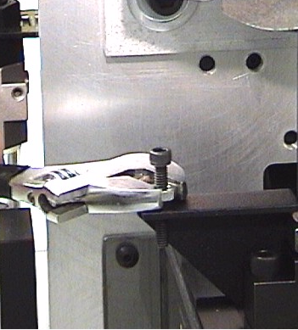
- If the air pressure is adequate, and there is no hanger jam, remove the front cover. Check the position of the indexing switch actuating screw. (Figures 15 & 16) The head of the screw should be in contact with the switch button without forcing it too far upwards.
Figure 14

To recalibrate the actuating screw position:

- Disconnect the air supply from the machine. The ram tip and actuating screw will fall downward slowly.
- Loosen the jam nut from the actuating screw, (Figure 14) and turn the screw clockwise so that it moves downward at least ¼”.
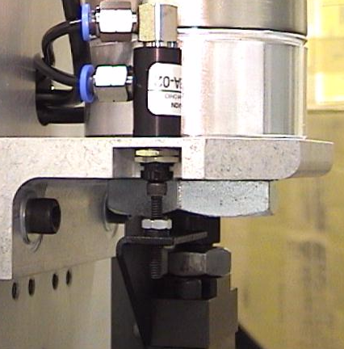
Correct actuating screw-switch position
Figure 15

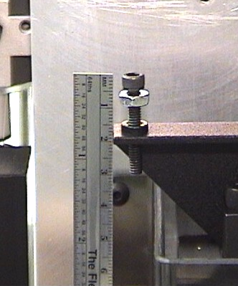
~21/32” or 16mm

Figure 16
Actuating screw

- Reconnect the air hose to the machine. Turn the actuating screw manually (counterclockwise) until the head of the screw fully depresses the indexing switch. Turn the screw back ½ turn (clockwise), and retighten the jam nut to lock the screw in position. The top of the screw head should be about 21/32” or 16mm above the bracket when correctly positioned. See Figure 16.
Page 14

- Depress the foot pedal or switch to test for proper operation of the indexing cylinder. See below for adjustment of indexing speed.

Calibrating the Indexing Speed

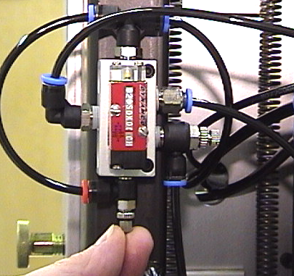
If the small cylinder that feeds hangers into the machine is operating either too rapidly or too slowly, indexing problems may result. The lower flow control valve (red connector) on the rear of the machine must be adjusted.
Figure 17
Valve B
Valve C

- Loosen the knurled jam nut on the valve as indicated. (Valve B, Figure 17)
- Tighten the valve adjustment knob fully.
- Open the knob ½ turn from the closed position.
- Test the machine by depressing the manual switch or foot pedal. You should be able to see the complete stroke of the indexing cylinder when the speed is properly set. Retighten the jam nut when you are satisfied that proper indexing speed has been achieved. Opening the valve increases hanger indexing speed, and vice-versa.

Calibrating the Secondary Air Valve

The flow control to the right, or Valve C (blue connector), regulates the volume of airflow to the indexing cylinder. To adjust the valve:

- Loosen the knurled jam nut on the valve as indicated. (Valve C, Figure 17)
- Tighten the valve adjustment knob fully.
- Open the knob 2 full turns from the closed position.
- Tighten the jam nut to lock the adjusting knob.

Setting the Ram Speed/ Cycle Time
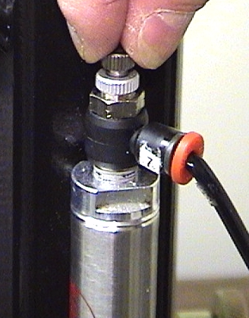
Figure 18
You must use a stopwatch set the total cycle time for the main cylinder. The total cycle time consists of a complete downward stroke and return back up to the starting position, not counting the foot pedal or pneumatic switch actuation and release time. The cycle time calibration is made with the pneumatic flow control valve located on the upper-right side of the machine, as seen from the rear. (Figure 18)

Safety Warning:
Raise the Saber carriage to the maximum height setting (2 ½”) before calibrating. Do not install hangers into the machine or place frame moulding under the ram. Keep hands away from the ram area!

Page 15
Loosen (counterclockwise) the knurled lock nut on the flow control valve, and then close (clockwise) the small adjusting knob fully (Figure 18). Open the adjusting knob ½ turn counterclockwise and make a timing test by actuating the foot pedal or manual pneumatic switch. Hold down the pedal/switch during the entire machine cycle. Continue to open/close the valve knob in small increments until the optimal cycle time is achieved. (see Figure 19)

Note: Opening the valve decreases the cycle/dwell time, and vice-versa. Actual cylinder speed is not affected.
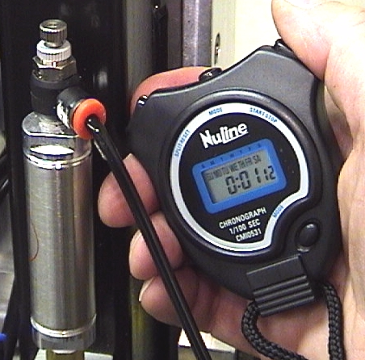
Figure 19
Correct cycle times for Saber ASM 400 is as follows:
1.1 – 1.2 seconds

When the calibration is complete, hold the adjusting knob in position and tighten the knurled locking

Page 16

- The Saber 400 ASM is an efficient and reliable machine, designed to be operated safely and maintained with minimal effort.

- Keeping the work area clean and clutter-free will allow the operator to work quickly and will prevent accidental damage to the machine and production materials.

- A clean dry cloth should be used to wipe down the machine; the surface of the base assembly should be protected from dents and abrasions. While the machine will operate properly despite such marks, it is up to the operator to safeguard the condition of your company’s product by taking care of the base and fence(s).

- Lubrication: Do not grease or oil any of the machine’s moving parts except the four (4) carriage channel locator nuts. Periodically apply a small amount of silicone-based lubricant to the channel and nuts.

- There are no parts to service or replace as part of a regularly scheduled plan. In fact, under normal use there is very little likelihood that a part will need replacement.

- Plastic safety guards, safety labels, replacement knobs, scales and the ram tip can be ordered from Frameware Inc..

- The machine’s parts and order numbers are listed to the left. Please refer to the drawings on page 4 to make sure you are ordering the correct item.

Description | Part Number
Air Regulator | 18-000
Air Valve | 18-001
Air Limit Valve | 18-002
Indexing Cylinder Assembly | 18-003
Main Air Cylinder | 18-004
Carriage Spring –  5/8" Dia. x 5" LG | 18-005
Carriage Spring –  1/2" Dia. x 5" LG | 18-006
Height Adjustment Knob | 18-007
T-Bar Shoe | 12-349
T-Bar Clamping Knob Assembly | 18-008
Hanger Ram Tip Assembly | 18-009
Hanger Shear Nose Assembly | 18-010
Ram Guard  (With Arrow Labels) | 18-011
Ram Guard Screw (BHSC  Screw, #8-32 x 1/2" LG) (4) | 12-848
Detent Height Settings Bracket & Scale | 18-012
Detent Height Settings Pointer | 18-013
Base Assembly (With Scales) | 18-014
Flat Head Socket Cap Screw,  #10-32 x 5/8" LG (2) | 18-015
Hex Key (Base-To-Frame Assembly Screws) | 18-016
Front Cover Assembly  (With Labels) | 18-017
Front Cover Screw, (BHSC #8-32 x 1/2" LG) (4) | 12-848
Warning Label  (Guards in Place) | 18-018
Caution Label  (Servicing) | 18-019
Air Volume Chamber | 18-020
Triangle Template (Square) | 12-625
TROUBLESHOOTING THE SABER

The machine fires prematurely. | The top edge of the frame is pressing against the activation switch before the side edge is squared on the fence. | Always position the side edge of the frame before pushing the top edge against the T-bar (i.e., the pneumatic switch).
A hanger is jammed in the machine. | In the unlikely event of a jam, one of two things may have happened. The hanger strip has been placed on the magazine incorrectly, or the hanger strip was bent or damaged during shipping or handling. | The operator must manually remove the jam by first disconnecting the air supply, then freeing the remaining hanger strip from the rear of the machine, and finally ejecting the jammed hanger. Only one hanger can ever be jammed because of the machine’s design.  To remove the hanger strip, locate the ram guard above the T-bar assembly and gently push up on the orange release lever. Do NOT force! Remove the hanger and then make sure the hanger strip is reloaded properly before reconnecting the air supply. (See page 6)
There is no air pressure. | The source of compressed air is disconnected or improperly connected to the Saber. | Re-check your air source and hose connections to make sure that you have correctly attached the Saber to your existing air supply system.  If the pneumatic drive still does not work properly, contact your Frameware Customer Service Representative for further advice.
There is insufficient air pressure. | Pressure settings are not properly set.  The machine is being used on material, or in a way for which it is not designed. | Check your company’s compressed air source to make sure that it is in proper working order. Verify that all settings are consistent with the recommendations listed on page 6 of this manual.
Page 15  Hanger is not fully installed. | (a) There is too much clearance between the picture frame and the ram tip at its extended position.  (b) There is not enough air pressure. | (a) Using the detent knobs on either side of the drive carriage, lower the height setting to an appropriate range. A ¼” clearance below the guard is sufficient.  (b) Increase air pressure until the hanger is fully installed.
Page 14  Hanger is not centered on the frame horizontally (left-right). | The fence is not positioned properly. | Adjust the Fence. Refer to page 9 in order to review measurement settings.
Hanger is not centered on the frame vertically (up-down). | The hanger need not be centered vertically on the top edge of the frame. However, if the hanger is not placed where the operator wants it, there is likely a problem with the measurements reflected on the scale on Scale B. | a) Adjust the T-bar scale. Refer to page 9 in order to review measurement settings.  b) Small frame adapter is not compensated for on T-bar scale. See page 12.
Hanger strip does not feed properly. | (a) The hanger strip may be slightly bent or twisted.  (b) One of the flow control valves is closed or clogged. | (a) The hanger strip can be fed with minimal misshape, however, it should be manually corrected if possible. If the strip is badly bent, the strip needs to be replaced.  (b) Adjust the flow control valve(s) to regulate air to the indexing cylinder. (See page 16 for more detailed instructions)
Frame will not release. | There may have been less than ¼” clearance between the ram tip and the picture frame. | Using the detent knobs on both sides of the carriage, raise the ram to an appropriate height setting range. A minimum ¼” clearance is necessary to avoid trapping the frame.
Page 15  Hanger is not fully installed. | (a) There is too much clearance between the picture frame and the ram tip at its extended position.  (b) There is not enough air pressure. | (a) Using the detent knobs on either side of the drive carriage, lower the height setting to an appropriate range. A ¼” clearance below the guard is sufficient.  (b) Increase air pressure until the hanger is fully installed.
Page 14  Hanger is not centered on the frame horizontally (left-right). | The fence is not positioned properly. | Adjust the Fence. Refer to page 9 in order to review measurement settings.
The machine fires prematurely. | The top edge of the frame is pressing against the activation switch before the side edge is squared on the fence. | Always position the side edge of the frame before pushing the top edge against the T-bar (i.e., the pneumatic switch).
A hanger is jammed in the machine. | In the unlikely event of a jam, one of two things may have happened. The hanger strip has been placed on the magazine incorrectly, or the hanger strip was bent or damaged during shipping or handling. | The operator must manually remove the jam by first disconnecting the air supply, then freeing the remaining hanger strip from the rear of the machine, and finally ejecting the jammed hanger. Only one hanger can ever be jammed because of the machine’s design.  To remove the hanger strip, locate the ram guard above the T-bar assembly and gently push up on the orange release lever. Do NOT force! Remove the hanger and then make sure the hanger strip is reloaded properly before reconnecting the air supply. (See page 6)
There is no air pressure. | The source of compressed air is disconnected or improperly connected to the Saber. | Re-check your air source and hose connections to make sure that you have correctly attached the Saber to your existing air supply system.  If the pneumatic drive still does not work properly, contact your Fletcher-Terry Customer Service Representative for further advice.
There is insufficient air pressure. | Pressure settings are not properly set.  The machine is being used on material, or in a way for which it is not designed. | Check your company’s compressed air source to make sure that it is in proper working order. Verify that all settings are consistent with the recommendations listed on page 6 of this manual.
Page 15  Hanger is not fully installed. | (a) There is too much clearance between the picture frame and the ram tip at its extended position.  (b) There is not enough air pressure. | (a) Using the detent knobs on either side of the drive carriage, lower the height setting to an appropriate range. A ¼” clearance below the guard is sufficient.  (b) Increase air pressure until the hanger is fully installed.
Page 14  Hanger is not centered on the frame horizontally (left-right). | The fence is not positioned properly. | Adjust the Fence. Refer to page 9 in order to review measurement settings.
Hanger is not centered on the frame vertically (up-down). | The hanger need not be centered vertically on the top edge of the frame. However, if the hanger is not placed where the operator wants it, there is likely a problem with the measurements reflected on the scale on Scale B. | a) Adjust the T-bar scale. Refer to page 9 in order to review measurement settings.  b) Small frame adapter is not compensated for on T-bar scale. See page 12.
Hanger strip does not feed properly. | (a) The hanger strip may be slightly bent or twisted.  (b) One of the flow control valves is closed or clogged. | (a) The hanger strip can be fed with minimal misshape, however, it should be manually corrected if possible. If the strip is badly bent, the strip needs to be replaced.  (b) Adjust the flow control valve(s) to regulate air to the indexing cylinder. (See page 16 for more detailed instructions)
Frame will not release. | There may have been less than ¼” clearance between the ram tip and the picture frame. | Using the detent knobs on both sides of the carriage, raise the ram to an appropriate height setting range. A minimum ¼” clearance is necessary to avoid trapping the frame.
Page 15  Hanger is not fully installed. | (a) There is too much clearance between the picture frame and the ram tip at its extended position.  (b) There is not enough air pressure. | (a) Using the detent knobs on either side of the drive carriage, lower the height setting to an appropriate range. A ¼” clearance below the guard is sufficient.  (b) Increase air pressure until the hanger is fully installed.
Page 14  Hanger is not centered on the frame horizontally (left-right). | The fence is not positioned properly. | Adjust the Fence. Refer to page 9 in order to review measurement settings.
TROUBLESHOOTING THE SABER

The machine fires prematurely. | The top edge of the frame is pressing against the activation switch before the side edge is squared on the fence. | Always position the side edge of the frame before pushing the top edge against the T-bar (i.e., the pneumatic switch).
A hanger is jammed in the machine. | In the unlikely event of a jam, one of two things may have happened. The hanger strip has been placed on the magazine incorrectly, or the hanger strip was bent or damaged during shipping or handling. | The operator must manually remove the jam by first disconnecting the air supply, then freeing the remaining hanger strip from the rear of the machine, and finally ejecting the jammed hanger. Only one hanger can ever be jammed because of the machine’s design.  To remove the hanger strip, locate the ram guard above the T-bar assembly and gently push up on the orange release lever. Do NOT force! Remove the hanger and then make sure the hanger strip is reloaded properly before reconnecting the air supply. (See page 6)
There is no air pressure. | The source of compressed air is disconnected or improperly connected to the Saber. | Re-check your air source and hose connections to make sure that you have correctly attached the Saber to your existing air supply system.  If the pneumatic drive still does not work properly, contact your Fletcher-Terry Customer Service Representative for further advice.
There is insufficient air pressure. | Pressure settings are not properly set.  The machine is being used on material, or in a way for which it is not designed. | Check your company’s compressed air source to make sure that it is in proper working order. Verify that all settings are consistent with the recommendations listed on page 6 of this manual.
Page 15  Hanger is not fully installed. | (a) There is too much clearance between the picture frame and the ram tip at its extended position.  (b) There is not enough air pressure. | (a) Using the detent knobs on either side of the drive carriage, lower the height setting to an appropriate range. A ¼” clearance below the guard is sufficient.  (b) Increase air pressure until the hanger is fully installed.
Page 14  Hanger is not centered on the frame horizontally (left-right). | The fence is not positioned properly. | Adjust the Fence. Refer to page 9 in order to review measurement settings.
TROUBLESHOOTING THE SABER

The machine fires prematurely. | The top edge of the frame is pressing against the activation switch before the side edge is squared on the fence. | Always position the side edge of the frame before pushing the top edge against the T-bar (i.e., the pneumatic switch).
A hanger is jammed in the machine. | In the unlikely event of a jam, one of two things may have happened. The hanger strip has been placed on the magazine incorrectly, or the hanger strip was bent or damaged during shipping or handling. | The operator must manually remove the jam by first disconnecting the air supply, then freeing the remaining hanger strip from the rear of the machine, and finally ejecting the jammed hanger. Only one hanger can ever be jammed because of the machine’s design.  To remove the hanger strip, locate the ram guard above the T-bar assembly and gently push up on the orange release lever. Do NOT force! Remove the hanger and then make sure the hanger strip is reloaded properly before reconnecting the air supply. (See page 6)
There is no air pressure. | The source of compressed air is disconnected or improperly connected to the Saber. | Re-check your air source and hose connections to make sure that you have correctly attached the Saber to your existing air supply system.  If the pneumatic drive still does not work properly, contact your Fletcher-Terry Customer Service Representative for further advice.
There is insufficient air pressure. | Pressure settings are not properly set.  The machine is being used on material, or in a way for which it is not designed. | Check your company’s compressed air source to make sure that it is in proper working order. Verify that all settings are consistent with the recommendations listed on page 6 of this manual.
Page 15  Hanger is not fully installed. | (a) There is too much clearance between the picture frame and the ram tip at its extended position.  (b) There is not enough air pressure. | (a) Using the detent knobs on either side of the drive carriage, lower the height setting to an appropriate range. A ¼” clearance below the guard is sufficient.  (b) Increase air pressure until the hanger is fully installed.
Page 14  Hanger is not centered on the frame horizontally (left-right). | The fence is not positioned properly. | Adjust the Fence. Refer to page 9 in order to review measurement settings.
Hanger is not centered on the frame horizontally (left-right). | The fence is not positioned properly. | Adjust the fence. Refer to page 9 in order to review measurement settings.
Hanger is not centered on the frame vertically (up-down). | The hanger need not be centered vertically on the top edge of the frame. However, if the hanger is not placed where the operator wants it, there is likely a problem with the measurements reflected on the scale on Scale B. | - Adjust the T-bar scale. Refer to page 9 in order to review measurement settings.  - Small frame adaptor is not compensated for on T-bar scale. See page 12.
Hanger strip does not feed properly. | - The hanger strip may be slightly bent or twisted.  - One of the flow control valves is closed or clogged. | - The hanger strip can be fed with minimal misshape, however, it should be manually corrected if possible. If the strip is badly bent, the strip needs to be replaced.  - Adjust the flow control valve(s) to regulate air to the indexing cylinder. (See Pg. 16)
Frame will not release. | There may have been less than ¼” clearance between the ram tip and the picture frame. | Using the detent knobs on both sides of the carriage, raise the ram to an appropriate height setting range. A minimum ¼” clearance is necessary to avoid trapping the frame.

